A Systematic Review of Functional Analyses Trainings Victor Ramirez, Ellie Kazemi, and Vahe Esmaeili California State University, Northridge
CalABA February 11th, 2017

- Functional analysis methodology is

Introduction

  - The most valid method of determining the underlying cause of problem behavior (Hanley, Iwata, & McCord, 2003)
  - Considered best practice for identifying function of problem behavior (Beaver, Iwata, & Lerman, 2013)
  - Evidenced to produce better treatment outcomes (Campbell, 2003)

- Skills required to complete a functional analysis
  - Designing
  - Implementing
  - Collecting data
  - Graphing
  - Interpreting results
  - Dealing with undifferentiated results
  - Selecting function-based intervention
- Some expertise is required

Purpose

Conducted a systematic review to determine what we currently know about training individuals to use functional analysis methodology

- Search Criteria
  - Search engine: PsycINFO o Search date: April 28, 2016 o Peer reviewed
  - English
  - Keywords
  - functional analys*
  - train* OR teach*

Method

  - staff* OR teacher* OR parent* OR caregiv* OR practitioner* OR student
- A total of 395 articles

- Inclusion criteria
  - Trained participants to utilize any functional analysis component skill
▪▪ (e.g., designing, graphing, selecting function-based interventions)

- Out of 395 articles:
  - 31 articles

- Two independent reviewers
  - Reviewed all 395 articles
  - 100% agreement on 31 articles to include
- Data Collection
  - Categorized:
▪▪ Characteristics of participants
▪▪ Functional analysis component skills trained
▪▪ Number of participants who met mastery
▪▪ Average training time per participant
    - (Package training time) + (Average session time)
- Interobserver agreement
  - Reviewed 39% of articles
  - 95% agreement on information categorized (range of 85%-100%)

Results

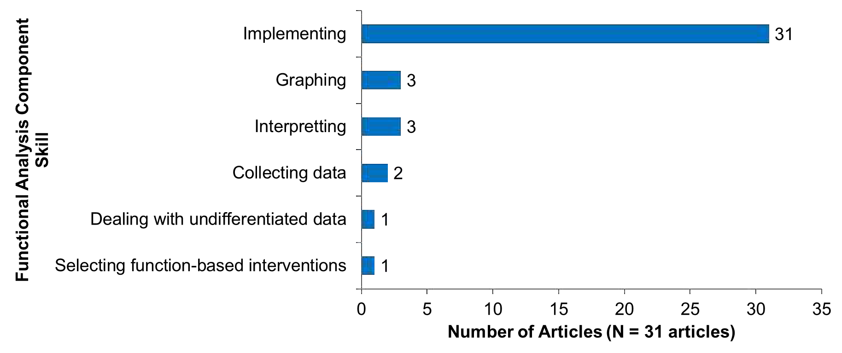
- FA Component Skills Trained

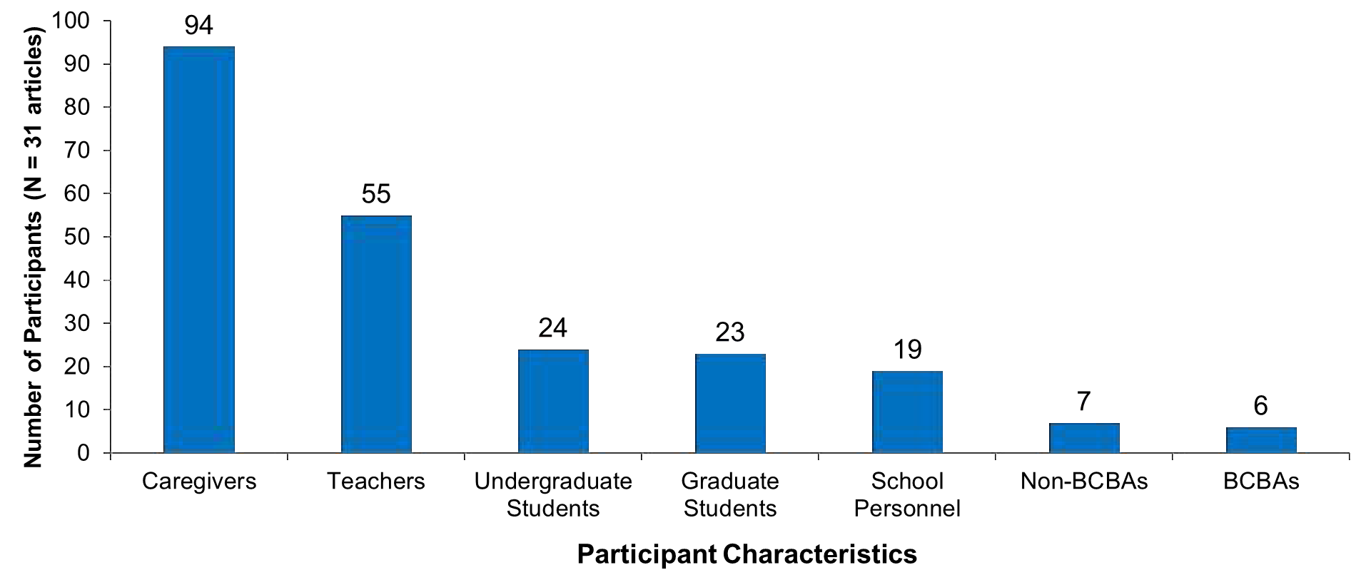
- Participant Characteristics

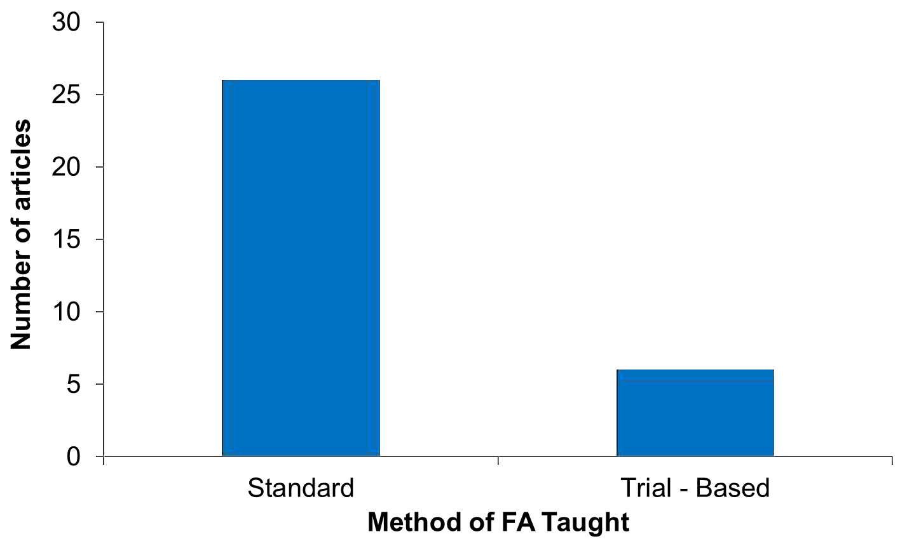
- Method of FA Taught

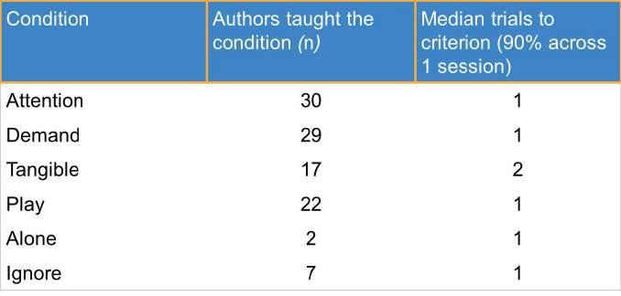
- Conditions trained & median trials to criterion

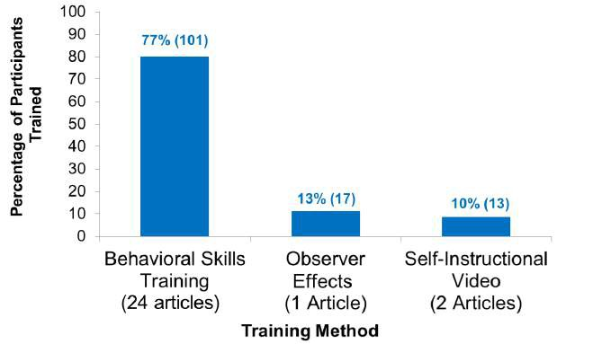
- Training Method (n = 131 participants)

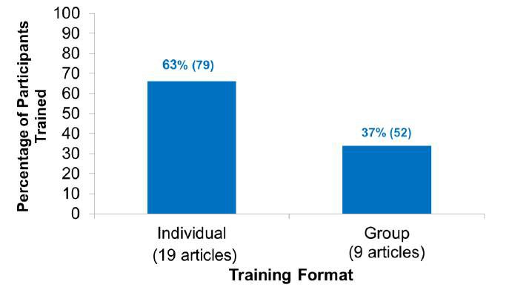
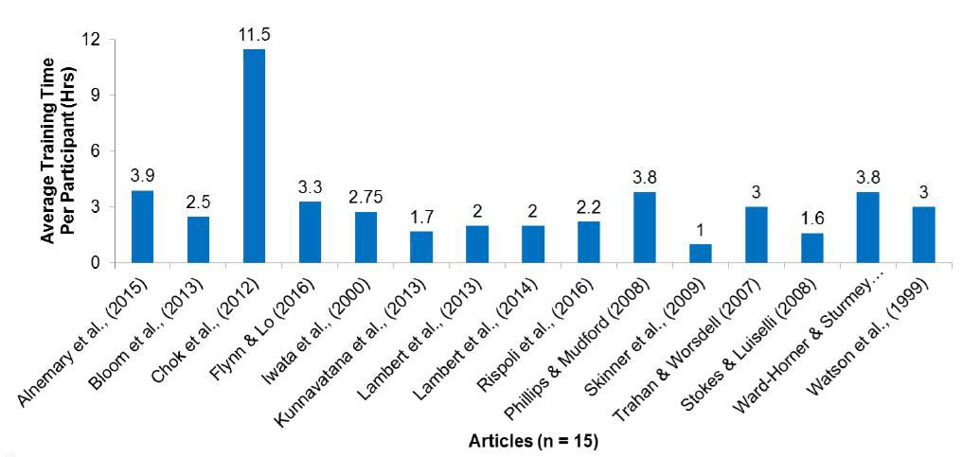
- Training Format (n = 131 participants)

- Average Training Time per Participants

Conclusions
  - Implementation can be trained in a short period of time
  - Individuals can learn implementation without prior knowledge of FAs
  - Many different individuals have been taught how to implement FAs successfully
  - Behavioral skills training has been established as an effective training method for
functional analysis
  - Group training may be as effective as individual training

Future Research
- Continue research in training all other FA component skills
- Researchers should report training time
- Training: Design of a functional analysis
- Training of all functional analysis component skills together

Selected References

Beavers, G. A., Iwata, B. A., & Lerman, D. C. (2013). Thirty years of research on the functional analysis of problem behavior. Journal of Applied Behavior Analysis, 46, 1-21.
Campbell, J. M. (2003). Efficacy of behavioral interventions for reducing problem behavior in persons with autism: a quantitative synthesis of single-subject research. Research in
Developmental Disabilities, 24(2), 120-138.
Hanley, G. P., Iwata, B. A., & McCord, B. E. (2003). Functional analysis of problem behavior: A
review. Journal of Applied Behavior Analysis, 36, 147-185.

