How to Float “0” on Excel

- Right click on your y-axis and click on “Formant Axis”

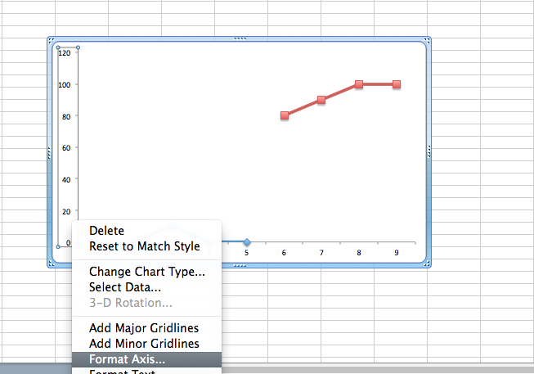
Click on “Format Axis

- Click on “Scale” and change the Minimum to a negative number. For example, if doing a percentage scale, change it to -10.0 (-10%). Make sure your major unit is 10.0 (10%). Then under “Horizontal Axis Crosses At”, change the number to your minimum number (-10.0 in our case).

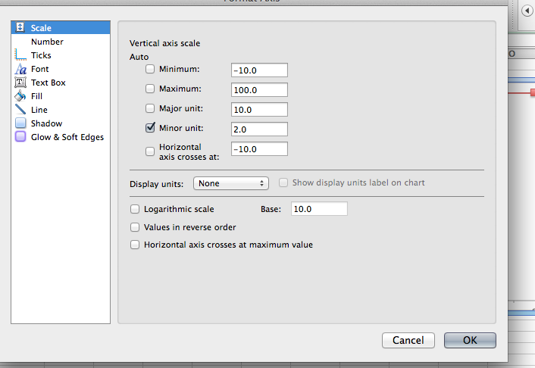
Make the axes cross at minimum number
Make minimum a negative number

- Your graph should now look like the picture below.

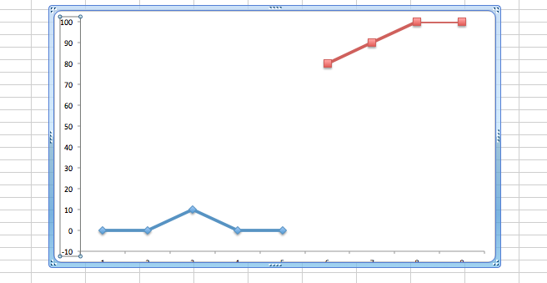
- Next you will cover the -10 by adding a shape.

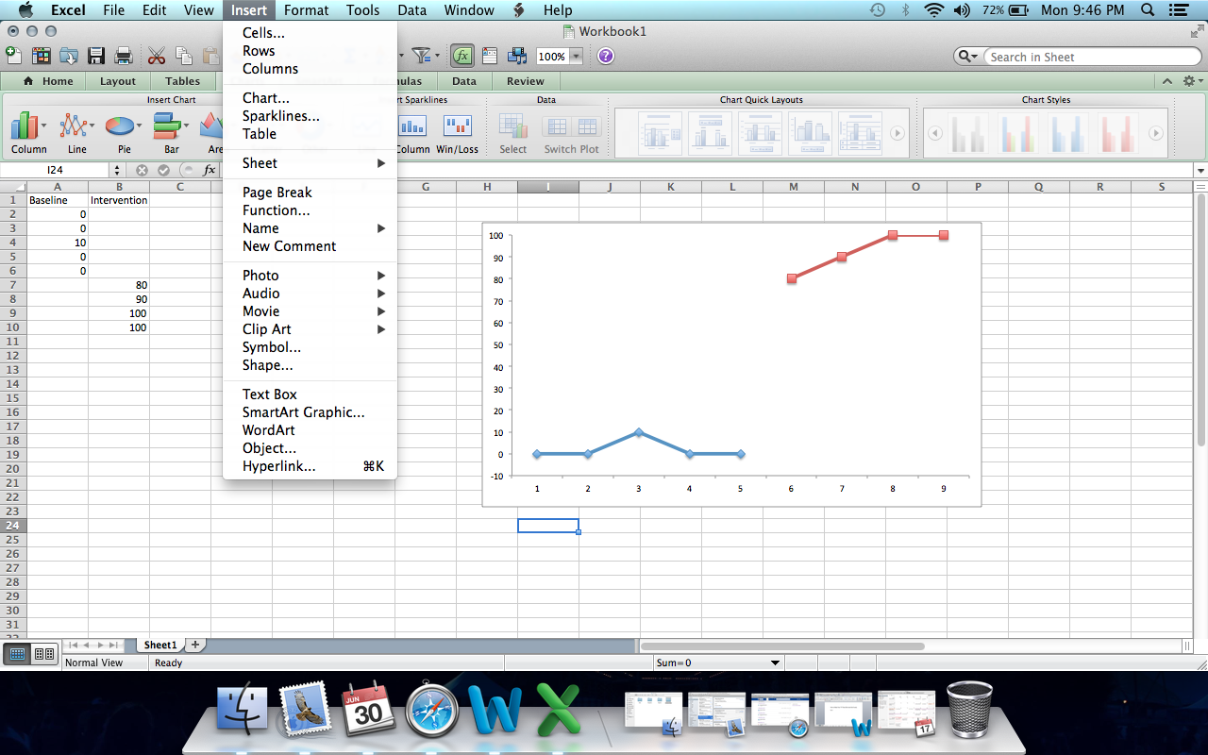

- Insert a rectangle and place over the negative number . In our case, we would put the rectable over the -10.0.

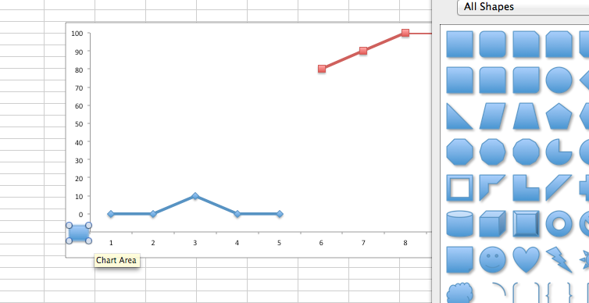
Make a rectangle over the negative number

- Format the rectable so that the fill is white and there is no line.
Make the fill white

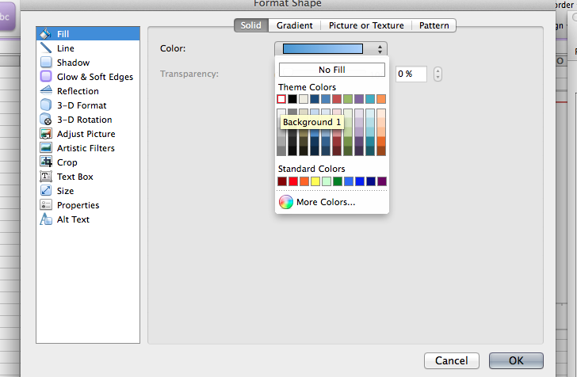

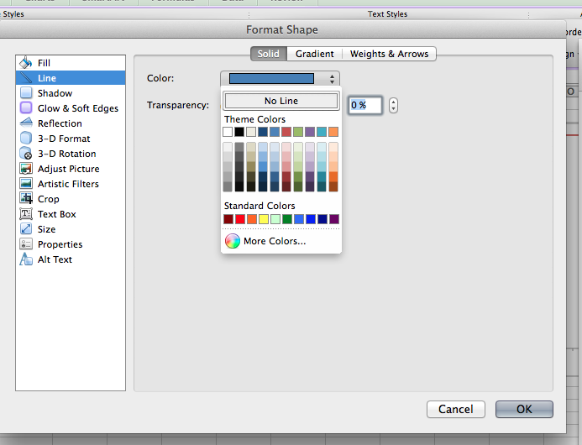
Make sure there is no line

- Your graph should look like this at the end

