Obesity and Healthy Living: Can Antecedent Interventions Alter College Students’ Snack Selections?

Shir Zion and Ellie Kazemi California State University, Northridge
CalABA February 11, 2017
ABAI May 29, 2017

Introduction

  - In the past 20 years, there has been a dramatic increase in obesity in the U.S. (Centers for Disease Control, 2010)

  - Two major contributing factors to obesity are (National Institutes of Health, 2012)
    - High calorie intake
    - Low levels of exercise

Background

  - Jeffrey, French, Raether, and Baxter (1994)
    - M = 368 consumers in a university office cafeteria
    - IV: Increased availability of fruits/veggies in salad bar + additional antecedent modifications

  - Olstad, Goonewardene, McCargar, and Raine (2015)
    - 17,262 items sold in two community pool kiosks
    - IV: Increased availability of healthier food/drink + additional antecedent modifications

A lack of
  - college student representation.

Gaps in the Literature

  - research relating to snack selection.
  - behavioral research.

Purpose

Evaluate the effect of
  - increasing availability of healthier snacks + adding variety and an advertisement of new healthier snacks on college students’ snack selection.

- 31 Graduate Students
- Age 22-34 years old
- Gender
o 8 males; 23 females

Participants and Setting

- California State University, Northridge classroom
- Once a week; 6:00pm-9:45pm

Material Selection Criteria

Healthier Snacks
Calories | ≤100
Fat | <7g

Less Healthy Snacks
Calories | >100
Fat | ≥7g

U.S. Department of Health and Human Services & U.S. Department of Agriculture, 2010; Bauersfeld, 2015

Materials Intervention 1 (Includes Less Healthy + Healthy)
Intervention 2 (Includes Les Healthy + Healthy + New Healthier + Advertisement)

Less Healthy
Salty – Lays Potato Chips
Sweet – Chewy Peanut Butter Bars Cheesy – Cheetos

Healthy
Salty - Popchips
Sweet – Fiber One Cinnamon Bars Cheesy – Ritz Crackers and Cheese Dip

New Healthier Salty – Funyons
Sweet – Fiber One Brownie Bars Cheesy – Pretzels and Cheese Dip

Advertisement (of new healthier snacks)

Response Measurement
- Percentage of students who selected healthier snacks per session.
- The mean of the total percentage of healthier snacks selected per condition.

IOA: Mean percentage of agreement between the data collectors across sessions
100% (Intervention 1); 100% (Intervention 2); 98.5% (Control)

Vocal Scripted Instruction:
  - Complete and submit index card

Procedures

  - Welcomed to make a snack selection during class break
  - Red ticket for snack
  - Blue ticket for water
  - Bring key tag to every class session
  - Blind to the purpose of the study
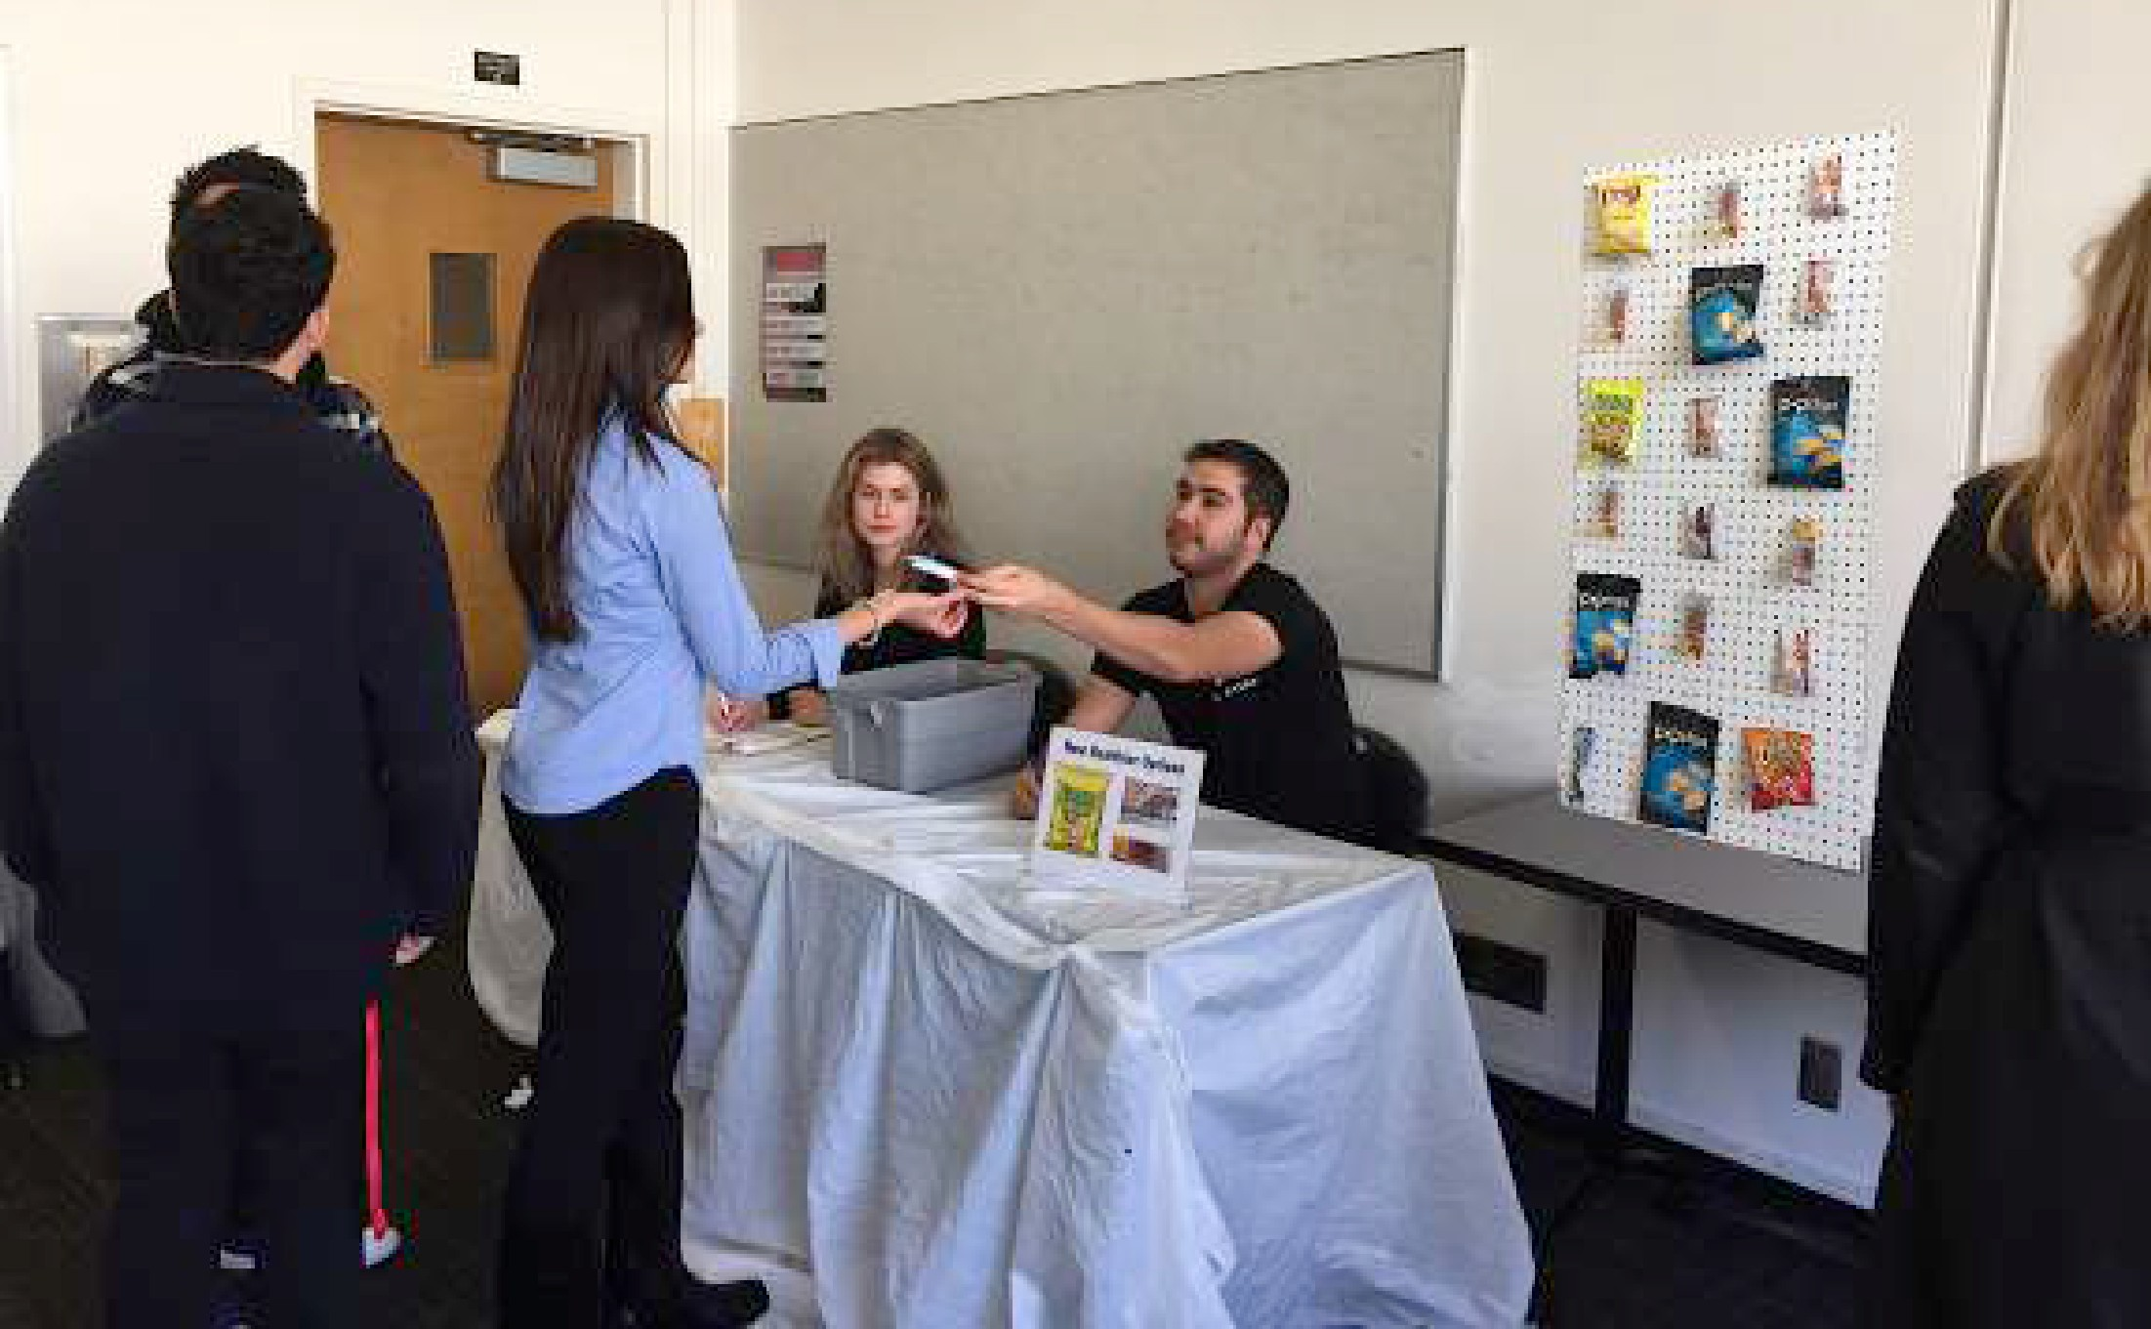

Group’s Snack Selection

Intervention 1 vs. Control Intervention 2 vs. Control

100

90
Percentage of Students Selecting
Healthier Snacks

80

70

60

50

40

30

20

10

0

Intervention 1

Control

Intervention 2

1 2 3 4 5 6 7 8 9 10 11 12 13

Sessions

Group’s Statistical Analyses

* p < .05

100
Mean of the Total Percentage of
Healthier Snacks Selected
90
80
70
60
50
40
30
20
10
0

M = 43% M = 50%

M = 80% *

Control Intervention 1 Intervention 2

Condition

Individuals who Always Selected (N=3)

Intervention 1 vs. Control Intervention 2 vs. Control

100
Percentage of Students Selecting
Healthier Snacks

90

80

70

60

50

40

30

20

10

0

Intervention 1

Control

Intervention 2

1 2 3 4 5 6 7 8 9 10 11 12 13

Sessions

Summary
  - Increasing availability of healthier snacks alone did not result in significant differences.
  - Increasing availability of healthier snacks + adding variety + advertising new healthier snacks did result in significant differences for the group.

Limitations include

Discussion

  - having access to vending machines,
  - no consensus,
  - reactivity,
  - students sharing food,
  - students eating before class, and
  - only using non-perishable snacks in this study.

Future Research
  - Extend the current study and add cost as an additional variable.
  - Isolate the component in Intervention 2
o For example: variety and advertisement

Selected References

Frazao E., Stewart H., Hyman J., Carlson A. (2012). Gobbling Up Snacks: Cause of Potential Cure for Childhood Obesity? Retrieved on April 1, 2015. http://www.ers.usda.gov/ amber-waves/2012-december/gobbling-up-snacks-cause-or-potential-cure-for- childhood-obesity.aspx#.Var28s5RHdl

Jeffery, R.W., French, S.A., Raether, C., Baxter, J.E.(1994). An Environmental Intervention to Increase Fruit and Salad Purchases in a Cafeteria. Preventative Medicine, 23, 788-792. DOI:10.1006/pmed.1994.1135

Olstad, D.L., Goonewardene, L.A., McCargar, L.J., Raine, K.D. (2015). If We Offer It, Will Children Buy It? Sales of Healthy Foods Mirrored Their Availability in a Community Sport, Commercial Setting in Alberta, Canada. Childhood Obesity. 11(2), 156-164. DOI: 10.1089/chi.2014.0131

  - Department of Health and Human Services & U.S. Department of Agriculture. (2015).
Dietary Guidelines for Americans. Retrieved on April 1, 2015, from http:// www.health.gov/dietaryguidelines/2015-dga-timeline.pdf

