Using Simulation-based Training and eLearning to Teach Students How to Conduct Functional Analyses
Michael Aragon, Ellie Kazemi, Victor Ramirez, & Vahe Esmaeili California State University, Northridge
CalABA Symposium February 11, 2017
ABAI Symposium May 29, 2017

Introduction
- Many Functional Analysis training packages focus on implementation (Ramirez et al., 2016)
- Training requires a lot of time and the use of expert trainers (Ramirez et al., 2016)
- The use of technology
  - Reduced cost & resources
▪▪ eLearning
▪▪ Robot simulating a client with problem behavior

Purpose
- Examine the effectiveness of a Standard FA training using
  - Instructional eLearning modules and
  - Simulations using a humanoid robot on implementation, data collection,
graphing, interpretation, and problem solving skills.

Participants & Settings
- Total of 7 graduate students (2 men, 5 women)
  - Enrolled in an advanced research methods class
  - Prior coursework on assessment and treatment of problem behavior
- eLearning Modules
  - Accessible in any setting with a computer via a Google Drive link
- Simulation-based Training
  - Observation rooms with one-way mirrors on the university campus

Response Measurement
- Knowledge of component skills measured by multiple choice and fill-in tests:
  - Data Collection
  - Interpretation
  - Problem Solving
  - Graphing

Pre-post test design
  - 20 items total (5 per component skill)
  - Calculated percentage correct on tests

Intervention: e-Learning Modules
- Five-part eLearning module on FA methods
  - Average time to completion was 6 hours
  - Components targeted knowledge test content
- Implementation (Iwata et al., 1994)
- Data Collection
- Graphing

- Interpretation (Roane et al., 2013)
- Problem solving (Chok et al., 2012)

Results of completing the modules

1 0 0

8 0 P r e - T e s t
P e r c e n t a g e o f C o r r e c t R e s p o n s e s

P o s t-T e s t

6 0

4 0

2 0

0
D a ta C o lle c tio n G r a p h in g In te r p r e ta tio n P r o b le m S o lv in g T o ta l T e s t S c o r e

Implementation Skills
- Performance monitoring tool (adapted from Ward-Horner & Sturmey, 2012)

Overall percentage correct
  - Mastery criteria: one session > 90%
- Trial-by-trial IOA
  - 90% agreement (range of 80%-100%)

- Standard FA condition properties
  - Participants informed of:

Intervention

▪▪ Results of preference assessment results
▪▪ Demand: Clap hands
  - 2-min. conditions across a humanoid robot
▪▪ Fixed order: Attention, play, & demand
- Total training time (M=25 min; Mdn= 18 min)

Implementation Results
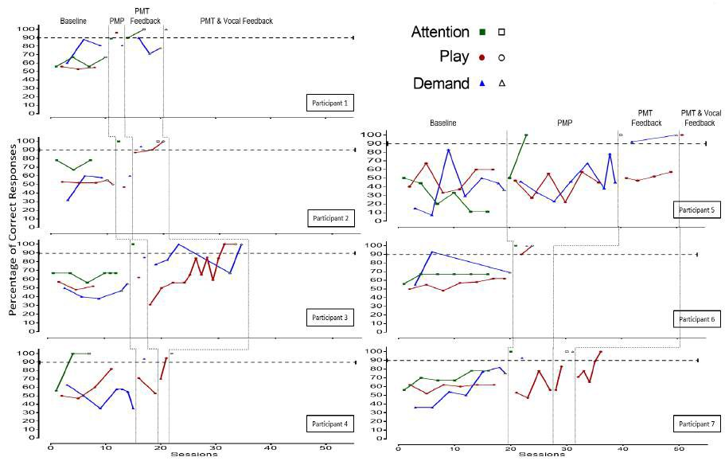

Summary
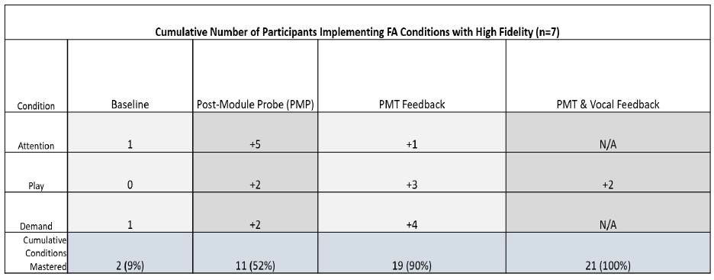

- eLearning

Limitations

  - Participants were graduate students
  - Improvements to weaker module components
- Test Development
  - Knowledge tests not counterbalanced to assess difficulty
  - Post-test results did not include implementation knowledge test (screening)
  - Test sections were too short (each section should be 10 questions)

Implications
- eLearning modules together with simulation-based training may be a great alternative to teach FA methodology in a time and cost efficient manner.

Selected References

Chok, J. T., Shlesinger, A., Studer, L., & Bird, F. L. (2012). Description of a practitioner training program on functional analysis and treatment development. Behavior Analysis in Practice, 5(2), 25.

Iwata, B.A., Dorsey, M.F., Slifer, K.J., Bauman, K.E., & Richman, G.S. (1994). Toward a functional analysis of self-injury. Journal of Applied Behavior Analysis, 27, 197-209. doi: 10.1901/jaba.1994.27-197 (Reprinted from Analysis and Intervention in
Developmental Disabilities, 2, 3-20, 1982)
Ramirez, V., Kazemi, E., & Esmaeili, V. (2016). A systematic review of functional analysis trainings. Unpublished raw data.

Roane, H. S., Fisher, W. W., Kelley, M. E., Mevers, J. L. and Bouxsein, K. J. (2013). Using modified visual-inspection criteria to interpret functional analysis outfomes. Journal of Applied Behavior Analysis, 46, 130–146. doi:10.1002/jaba.13

WardIHorner, J., & Sturmey, P. (2012). Component analysis of behavior skills training in functional analysis. Behavioral Interventions, 27(2)

