Workplace Conflict for Board Certified Behavior Analysts Chelsea Carter, Ellie Kazemi, Shelby Jones, Christina Melanie Saez California State University, Northridge
CalABA February 11, 2017

Introduction

Studdert et al. (2003) defined conflict as:

“dispute, disagreement, or difference of opinion related to the management of a patient”, and “involving more than one individual and requiring some decision or action”

Prevalence and Impact of Workplace Conflict

Prevalence of conflict

    - Healthcare: 72% (Azoulay et al., 2009)
    - Education: 83% (Tantleff-Dunn, Dunn, & Gokee, 2002)

Negative impact of conflict

    - Accounting
      - Lowered job satisfaction (Shafer, 2002)
      - Higher intention to leave (Greenhaus, Parasuraman, & Collins, 2001)
    - Education/Special Education
      - Higher burnout (Schwab & Iwanicki, 1982; Crane & Iwanicki, 1986)

Resources for Resolving Workplace Conflict

Behavior Analysis

    - 25 Essential Skills & Strategies for the Professional Behavior Analyst (Bailey & Burch, 2010)
    - Recommendations for Detecting and Addressing Barriers to Successful Supervision (Sellers, LeBlanc, & Valentino, 2016)

Social and Educational Psychology

    - How to deal with “difficult people” (Conlow & Watsabaugh, 2009; Harvard Business School Press, 2004)

    - Bargaining/Negotiation (Strom-Gottfried, 1998)
    - Assess & Diagnose (Gerardi, 2003)

Purpose of Our Study

Conduct a survey using a representative sample of Board Certified Behavior Analysts (BCBAs) to establish preliminary information on workplace conflict for BCBAs

Participants

National distribution through BACB Listserv:

• 15,818 BCBAs & BCBA-Ds (09/16/16)
      - 3,982 (25.2%) opened the email
▪▪ 295 (7.4%) attempted the survey
        - 209 (5.2%) completed the survey

  - Professional Employment Survey: A Preliminary Report (2014) – National distribution by Association of Professional Behavior Analysts (APBA)

    - 12,588 BCBAs & BCBA-Ds received invitation
      - 925 (7.3%) completed the survey

Participant Demographics

Demographic Item | Median (SD)
Age | 35 (9.9)
 | % of Sample (N=209)
Gender  Female | 89%
Degree Designation  Behavior Analysis or Applied Behavior Analysis, Psychology with focus in ABA, or Psychology/Clinical Psychology | 52%
Years with BCBA credential  A little over 1 to 6 years | 61%
Years as supervisor in ABA  A little over 3 to 6+ years | 60%
Number of clients  6-13+ | 76%
Settings where services are primarily provided  Public School, Home-based, School + Home | 66%
Highest Degree  Master’s degree | 85%

Workload  Full-time | 84%
Primary Responsibilities  Oversee cases & supervise interventionists, supervise the clinical team | 56%

Procedures

Survey details

    - All responses anonymous, no identifying information collected
      - IRB exempt
    - Each question included a “prefer not to state” option
    - Conflict specific questions included “do not work with this group” option
      - 25 Question Items
      - 25-30 minutes to complete

Our Questionnaire

10 Demographic Questions (Kazemi, Shapiro, & Rylander, 2015)

- How often do you deal with conflict with…? (Studdert, et al. 2003; Breen, Abernethy, Abbott, & Tulsky, 2001; Azoulay et al., 2009)
  - 11 different individuals (e.g., teachers) with whom BCBAs may encounter
conflict
  - Likert scale 0 – 5 (e.g. 0 - Do not work with this group, 5 – Daily)
- How often is conflict unresolved with…? (Tantleff-Dunn, Dunn, & Gokee, 2002)
  - 11 different individuals with whom BCBAs may encounter conflict
  - Likert scale 0 – 5 (e.g. 0 - Do not work with this group, 5 – Daily)

Our Questionnaire

Other factors related to Workplace Conflict – 13 Total Items

- 2 items: Turnover (Kazemi, Shapiro, & Rylander, 2015; Shafer, 2002)
- 2 items: Job satisfaction (Kazemi, Shapiro, & Rylander, 2015; Shafer, 2002)
- 1 item: Lost cases
- 2 items: Prior training (Azoulay et al., 2009)

Results

Total Rate of Workplace Conflict

Questions: “How often do you deal with conflict with…”

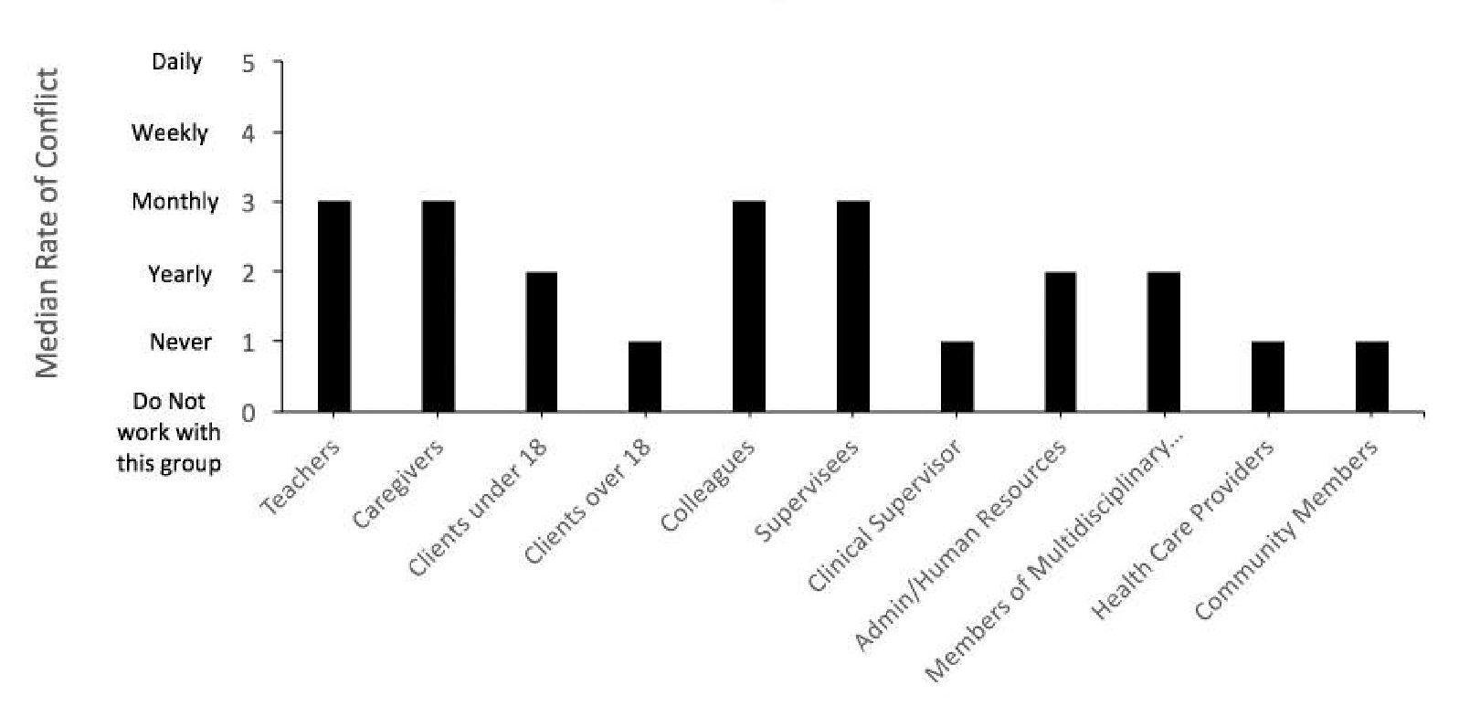

Type of Degree Related to Workplace Conflict?

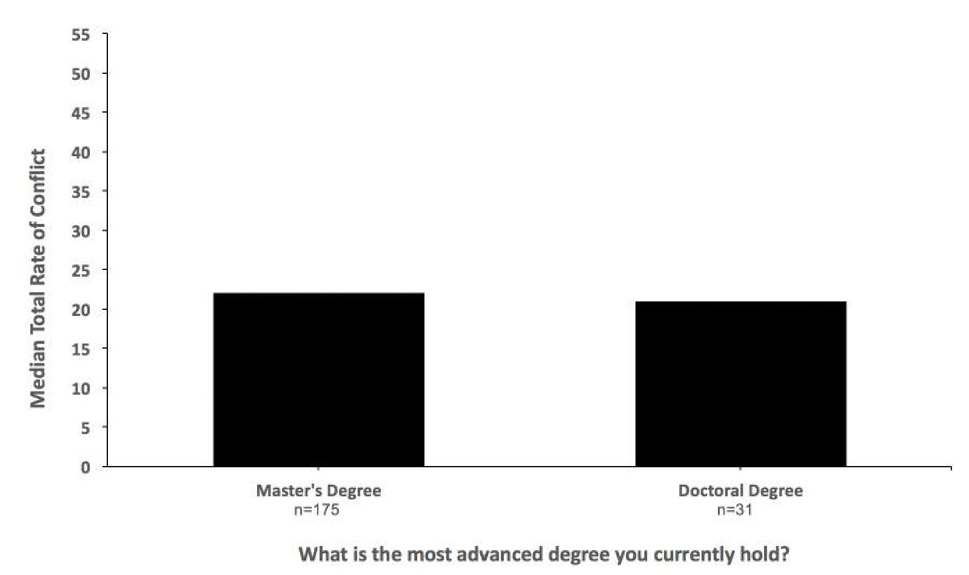

Gender Related to Workplace Conflict?

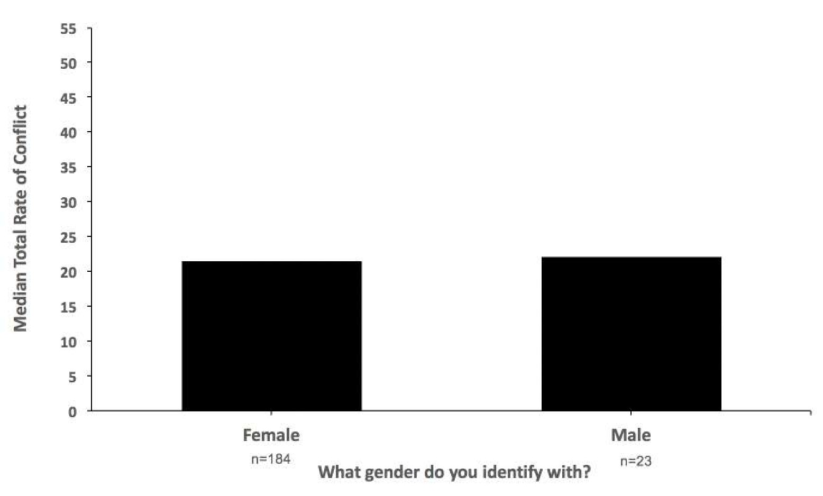

Years of Experience Related to Workplace Conflict?

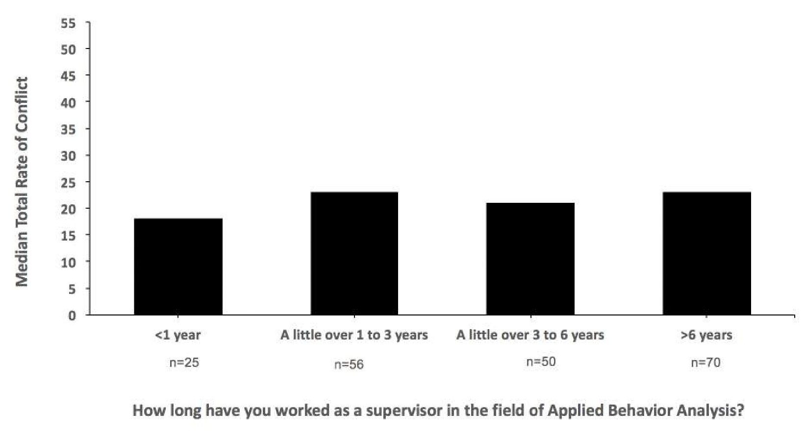

Setting of Service Provision Related to Workplace Conflict?

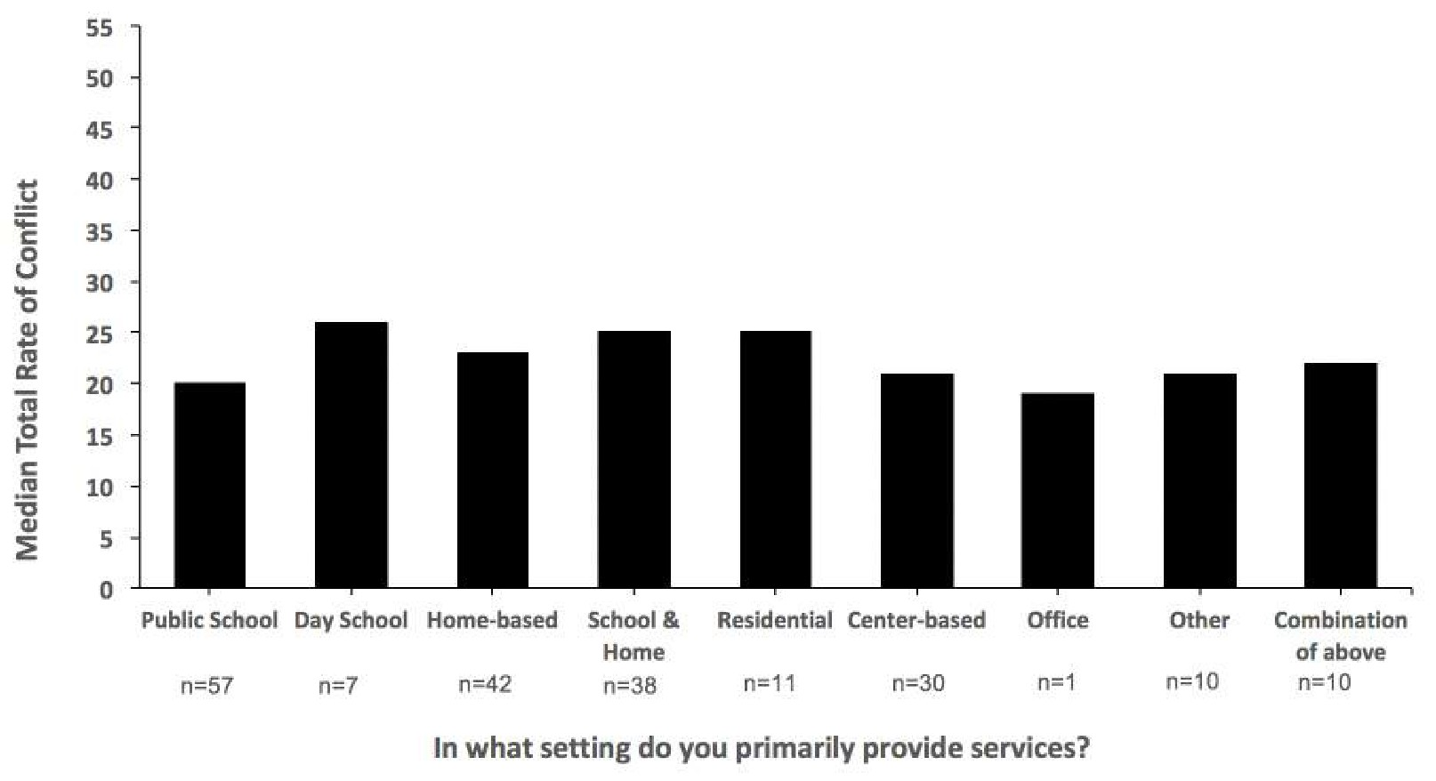

Primary Job Duties Related to Workplace Conflict?

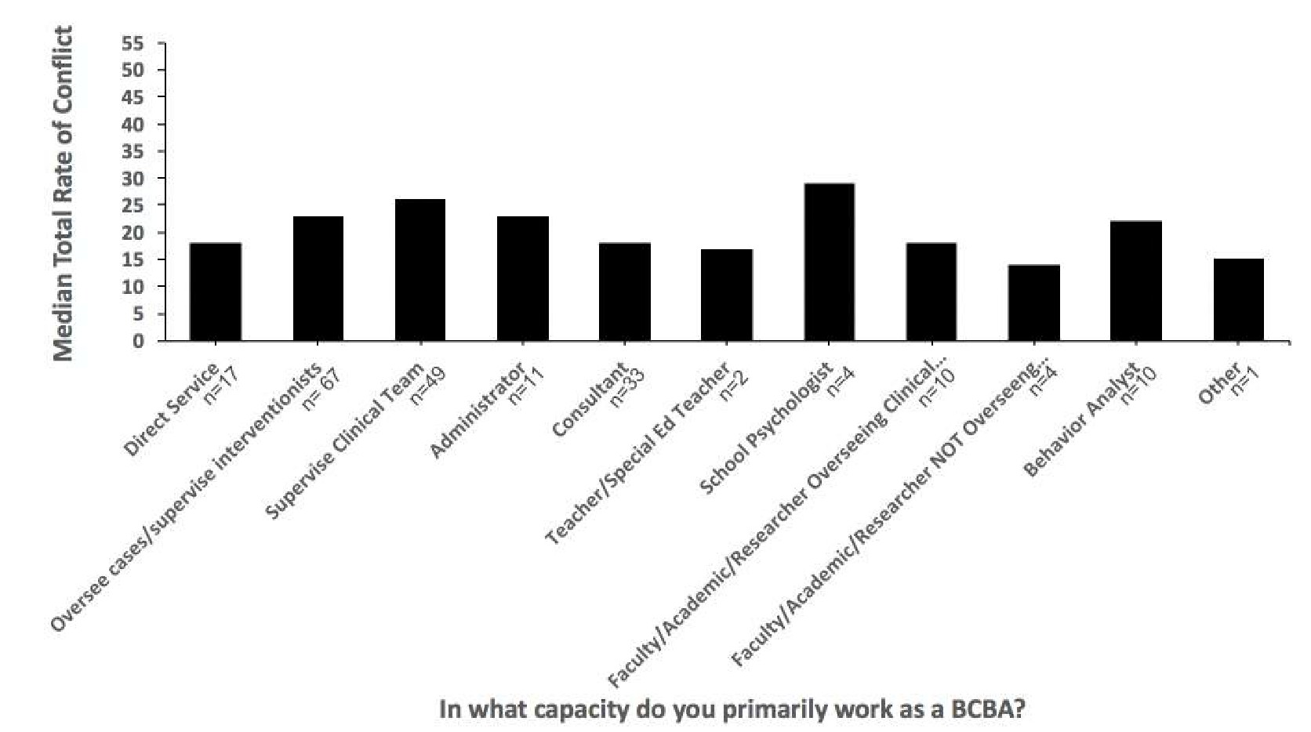

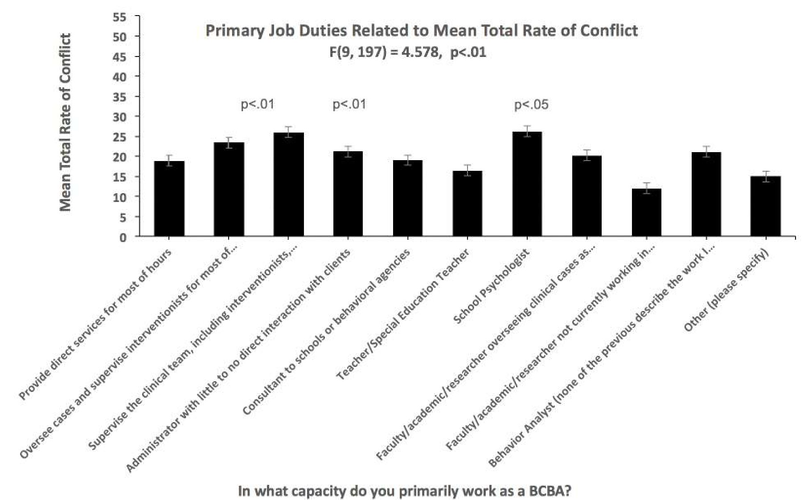
ANOVA

Number of Clients Related to Conflict?

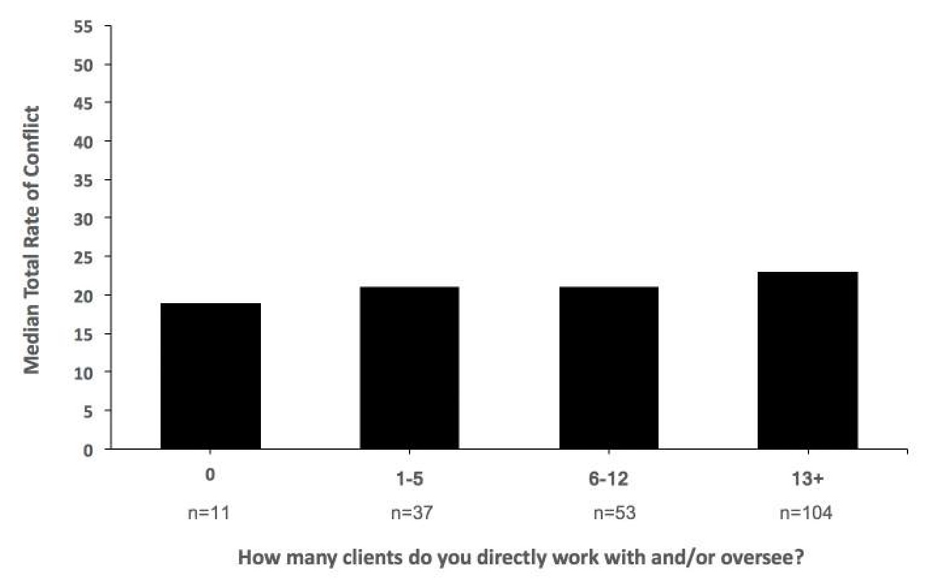

ANOVA

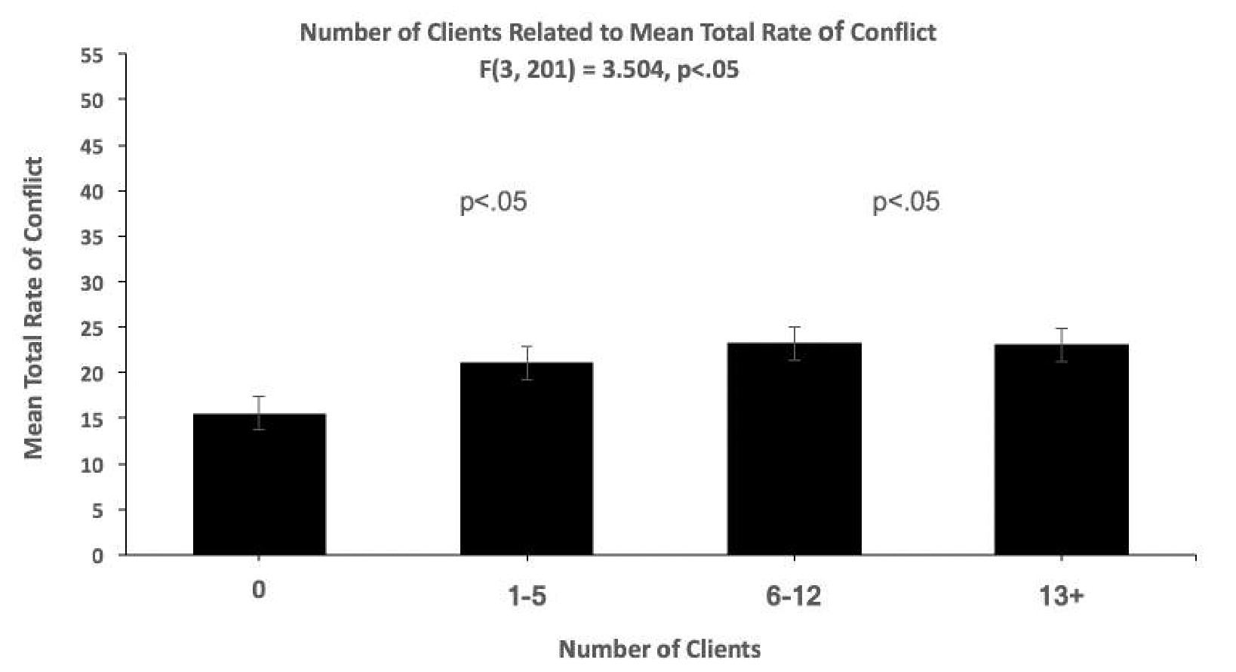

Turnover & Total Rate of Conflict

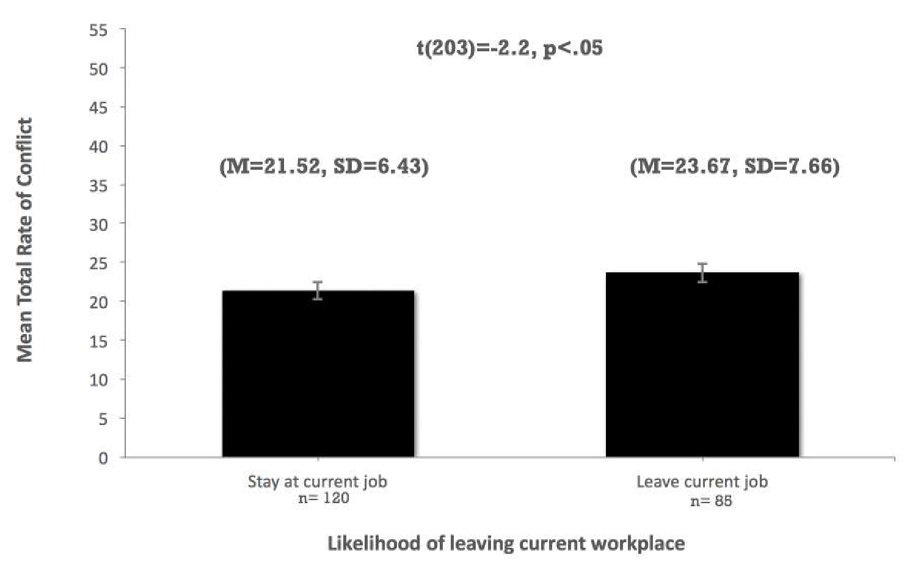

Lost Cases

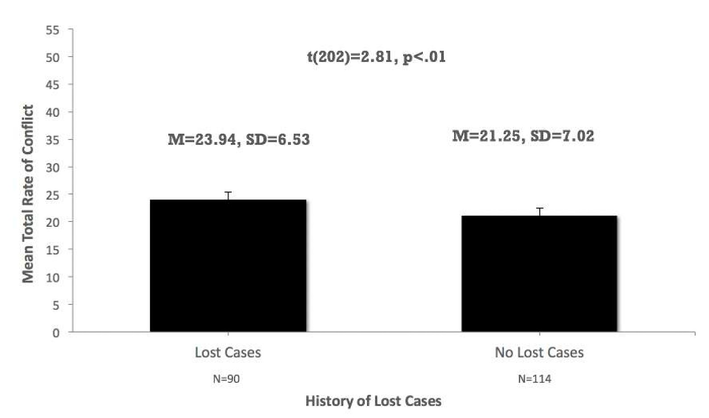

Total Rate of Unresolved Conflict

Questions: “How often is conflict unresolved with…”

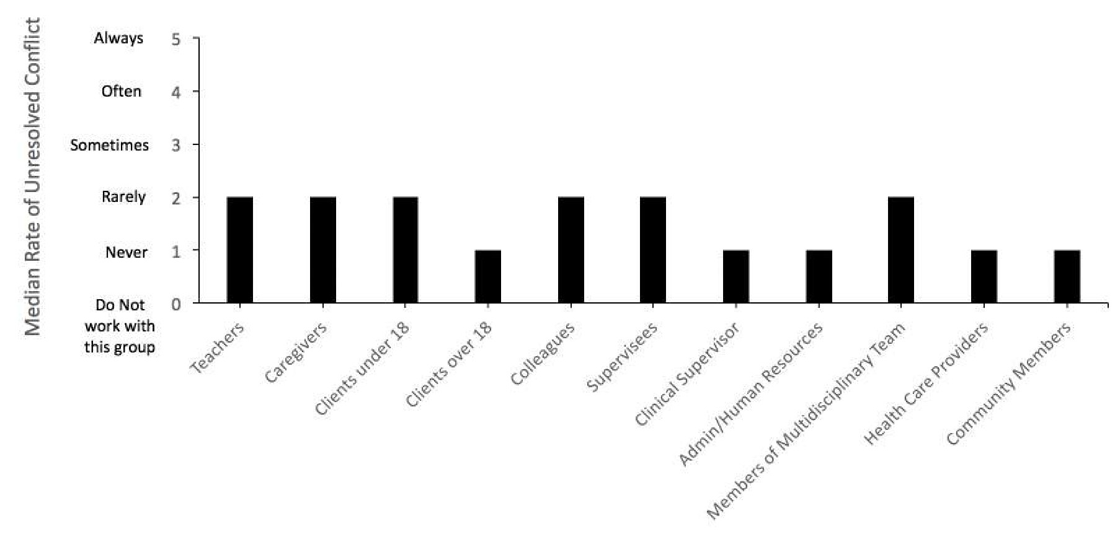

Turnover & Total Rate of Unresolved Conflict

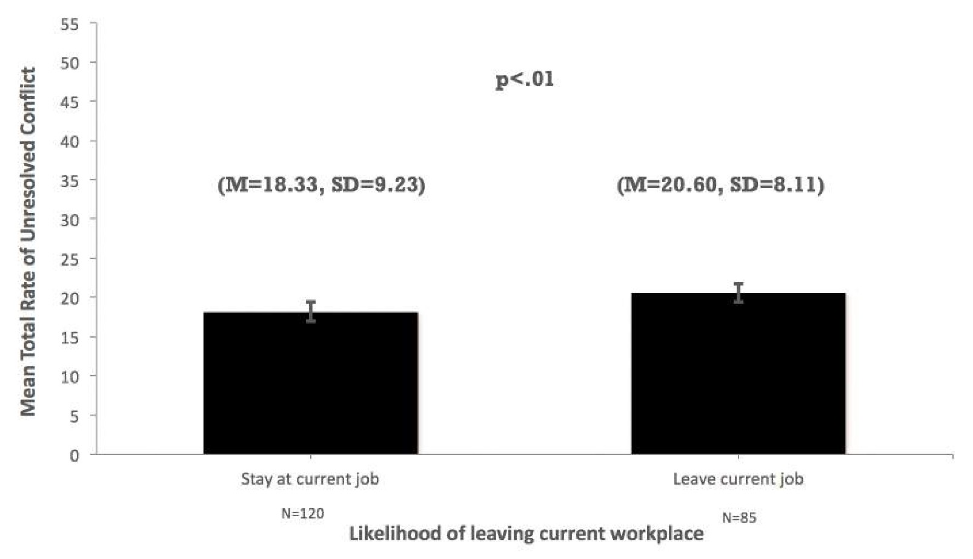

Are Participants Interested in Receiving Conflict Resolution Training?

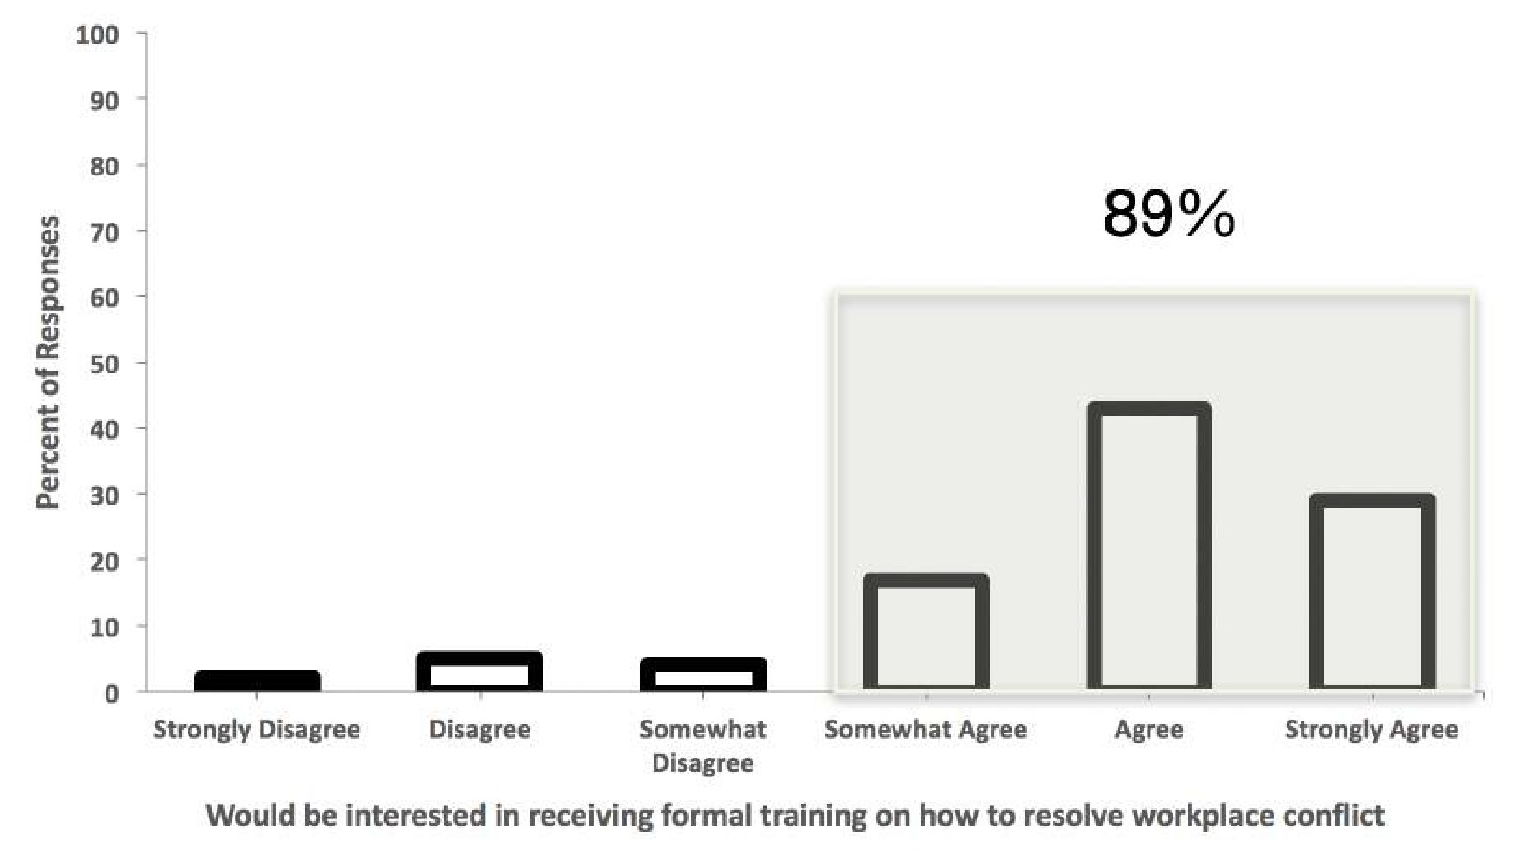

Do Participants Feel Conflict Impacts Job Satisfaction?

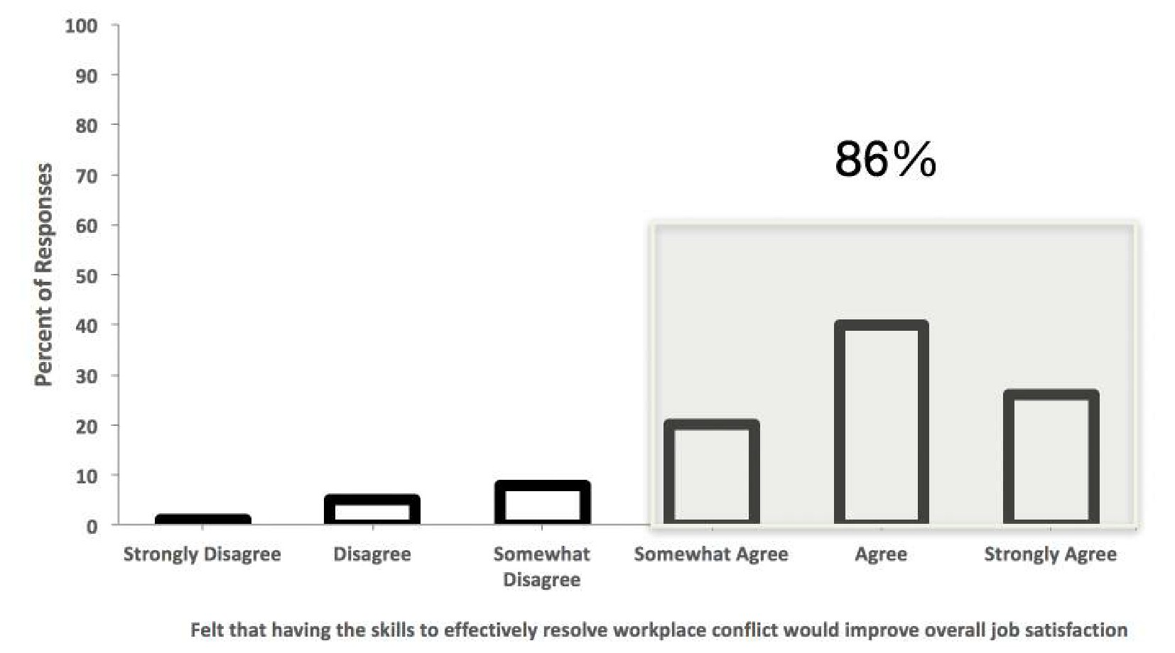

Conclusions – What Have We Learned About Workplace Conflict?

- Occurs most often with teachers, caregivers, colleagues, and supervisees
- Significant group differences related to
  - Number of clients
  - Turnover
  - Lost cases
- Resolution skills would improve job satisfaction
- Interest in receiving formal training

Limitations

- Self-report rather than direct observation
- Low response rate
  - No second wave of surveys
- Snowball sample
  - Possibly more applicable for those who find conflict interesting
- No definition provided of unresolved conflict
- No specific information on prior training obtained

Future Directions

- Look into current models of Conflict Resolution Training

- Determine the key steps required for effective Conflict Resolution

References

Azoulay E, Timsit JF, Sprung CL, et al. (2009). Prevalence and factors of intensive care unit conflicts: the conflicus study. American Journal of Respiratory and Critical Care Medicine, 180(9). 853-60.

Bailey, J., & Burch, M. (2010). 25 essential skills & strategies for the professional behavior analyst: Expert tips for maximizing consulting effectiveness. New York, NY: Routledge.

Breen, C.M., Abernethy, A.P., Abbott, K.H., & Tulsky, J.A. (2001). Conflict associated with decisions to limit life-sustaining treatment in intensive care units. Journal of General Internal Medicine, 16. 283-289.

Conlow, R., & Watsabaugh, D. (2009). Handling difficult people and situations lead people through adversity. Rochester, N.Y.: Axzo Pres.

Crane, S.J. & Iwanicki, E.F. (1986). Perceived role conflict, role ambiguity, and burnout among special education teachers. RASE, 7. 24-31.

Gerardi, D. (2003). Conflict Management Training for Health Care Professionals. Association for Conflict Resolution Quarterly. http://www.mediate.com/articles/gerardi4.cfm

Greenhaus, J.H., Parasuraman, S., & Collins, K.M. (2001). Career involvement and family involvement as moderators of relationships between work-family conflict and withdrawal from a profession. Journal of Occupational Health Psychology, 6(2). 91-100.

Harvard Business School Press. (2004). Dealing with difficult people. Boston, MA.

Kazemi, E., Shapiro, M.., & Rylander, A. (2015) Predictors of intention to turnover in behavior technicians working with individuals with autism spectrum disorder. Research in Autism Spectrum Disorders, 17. 106-115.

Schwab, R.L. & Iwanicki, E.F. (1982). Perceived role conflict, role ambiguity, and teacher burnout. Educational Administration Quarterly, 18. 60-74.

Sellers, T.P, LeBlanc, L.A., & Valentino, A.L. (2016). Recommendations for detecting and addressing barriers to successful supervision. Behavior Analysis in Practice, 9. 309-319.

Shafer, W.E. (2002). Ethical pressure, organizational-professional conflict, and related work outcomes among management accountants. Journal of Business Ethics, 38. 263-275.

Strom-Gottfried, K. (1998). Applying a Conflict Resolution Framework to Disputes in Managed

Care. SocialKazemi & Carter (2016) Workshop Notes 7Work, 43, 393-401.

Studdert D.M., Mello M.M., Burns J.P., Puopolo A.L., Galper B.Z., Truog R.D., & Brennan T.A. (2003) Conflict in the care of patients with prolonged stay in the ICU: types, sources, and predictors. Intensive Care Med, 29.1489–1497.

Tantleff-Dunn, S., Dunn, M.E., & Gokee, J.L. (2002). Understanding faculty−student conflict: student perceptions of precipitating events and faculty responses. Teaching of Psychology, 29(3), 197-202.

